The following are responses to reviewers 1 and 2. Responses to the reviewers are in blue, while edits made to the manuscript and copied here are written in red.

Reviewers' comments:
Reviewer 1: I thank the authors for their revision. I may be a bit picky but I still have few minor concerns:
I like the new fig4. However, if I understand correctly, I believe, in the last box CL and CR should be replaced by CmuL and CmuR. Or maybe in the "second stage" box RmuL should be replaced by RL ?
Yes, in the last box of the model diagram in Figure 4, C_{L} and C_{R} represent the model responses for the monocular channels. We agree with the reviewer that it would be clearer to include μ in the labels and have updated the figure accordingly at line 61 and line 105.
S and Z are not there "to prevent division by 0"

Agreed, S and Z are responsible for determining the overall sensitivity of the model, but, by their nature, they also prevent division by 0. However, as this is not their primary purpose, we have removed the statement from the manuscript for each equation in which S or Z is described.
"We agree with the reviewer, the rationale for the two types of stimulus flicker could have been clarified in the introduction. …" [ … ] "Steady-State Visually Evoked Potentials offer a unique opportunity to bridge the gap between models developed from psychophysical data and neuroimaging, as responses to stimulus contrast (i.e., SSVEP amplitude) are directly associated with behavioral sensitivity to contrast (Norcia, 2015; Wade & Baker, 2025). Two common stimulus presentation protocols are used to generate SSVEPs: a sinusoidal On/Off flicker, where the stimulus alternates between a blank background (0\% contrast) and the peak contrast, and sinusoidal counterphase flicker, where the stimulus alternates in phase (i.e., the black regions become white, and the white regions become black). On/Off flicker activates different populations of on and off-cells independently once per cycle, generating frequency-following responses at the frequency of the sinusoidal modulation (1F). On/Off flicker can also generate SSVEPs at the odd and even integer harmonics (2F, 3F, 4F, etc.), which reflect nonlinear processing in the visual system (Regan, 1988). Counterphase flicker will generate two transients per cycle, resulting in SSVEPs at the even harmonics of the flicker frequency (2F, 4F, 6F, etc.). These frequency doubling responses are argued to provide a cleaner measure of nonlinear visual responses (Kim et al., 2011; Skottun, 2007). Utilizing both stimulation protocols enables a comprehensive description of linear and nonlinear visual processes, thereby generating the data necessary to evaluate psychophysical models of visual perception. "
-> So both protocols are designed to assess nonlinear responses?
Yes, both stimulation protocols can be used to assess nonlinear responses in observers' SSVEPs. However, only the On/Off stimulation protocol can generate a linear (1F) response to the stimulus, which is required to adequately probe our models. The two stimulation protocols were included in our study to generate the largest possible stimulus set for model evaluation.

To clarify this point, we have edited the last sentence of the SSVEP paragraph in the introduction. It now reads as:
L149. Using both stimulation protocols yields the data needed for a comprehensive description of linear and nonlinear visual processes, thereby enabling evaluation of psychophysical models of visual perception.
Reviewer 2:
I must express dissatisfaction with the authors' reply.
0. My unnumbered comment "I'm not sure what exactly the SSVEP tells us about visual processing," was completely ignored. The authors didn't even include it with my numbered comments. (My fault, I guess, for failing to give it a number.)

Apologies for missing this comment, but this sentence read very much as rhetorical, and it was not clear how this comment was intended to improve the quality of this manuscript other than to dismiss it entirely.

Steady-state Visually Evoked Potentials are neural responses to stimuli that are presented periodically at, in our case, a relatively rapid rate. Presenting stimuli in this way elicits a steady-state response in which the visual system resonates at the stimulus rate. Typically, a steady-state response in the EEG signal appears as the sum of two sine waves, one at the stimulus oscillation frequency and one at twice that frequency - as explained by Luck in his 2014 book on event-related potential technique - but a more complex pattern can also be observed, as we have here in our study. SSVEPs offer a unique approach to quantifying non-linearities in biological systems and thus generate the necessary data to constrain models of human vision. Not only does the model need to capture the response to the stimulus at the fundamental frequency (3Hz), but also to generate the non-linearities observed in the data.

While the reviewer may not be aware of SSVEPs' role in visual perception, we do not believe an explanation falls within the purview of this manuscript. SSVEPs have a long history in vision studies, and we refer the reviewer to a review written by Norcia in 2015,
Norcia, A. M., Appelbaum, L. G., Ales, J. M., Cottereau, B. R., & Rossion, B. (2015). The steady-state visual evoked potential in vision research: A review. Journal of Vision, 15(6), 4. https://doi.org/10.1167/15.6.4
in addition to one of the original manuscripts demonstrating the value of SSVEPs in characterizing biological systems.
Regan, M. P., & Regan, D. (1988). A frequency domain technique for characterizing nonlinearities in biological systems. Journal of Theoretical Biology, 133(3), 293–317. https://doi.org/10.1016/S0022-5193(88)80323-0
1. The authors claim, "Sensitivity in our models is implicitly limited by late noise, as is assumed by all contemporary models of binocular vision." I say: citation needed. The authors continue, "It has been clear for some time now that the proposed architecture by Campbell and Green does not capture the behavioral results of binocular summation." Again, I say: citation needed. It seems this comment, which the authors concede is correct, was nonetheless effectively dismissed by them. There seems to have been no attempt to address it in the manuscript.

We conceded you were correct in describing our models as implicitly limited by late noise. We did not include citations in our previous replies, but are happy to do so now.

The inability of the original models to capture the behavioural results of binocular summation is discussed (and demonstrated) in Meese, Georgeson, and Baker (2006). However, the limitations of the Campbell and Green description of binocular summation, whereby the model can only return sqrt(2) improvement when the noise in one eye is ignored, or that the observer is able to respond selectively to the monocular pathway in monocular trials is recognized in the original Campbell and Green (1965) manuscript and by Blake, Sloane, and Fox (1981). Many models of binocular summation today assume late noise; many of these are variants of the two-stage contrast gain control model, but others exist as well and are reviewed in Blake and Wilson (2011).

The goal of this manuscript is to probe a well-established model of binocular summation, first introduced in 2006 by Meese et al., and the most recent version, developed in 2016 by Georgeson et al., that includes phase-selective and monocular channels, using novel SSVEP data. Our approach to probing this model was to begin with its simplest iteration and increase its complexity up to the 2016 model proposed by Georgeson. This allowed us to demonstrate the computational elements required in the two-stage contrast gain control model architecture to explain our effects. We are not arguing for a novel model of binocular summation, and as such, believe that explaining the original descriptions of binocular summation that are not relevant to our current model architecture is beyond the scope of this manuscript.

To make this point clear, we have made the following amendments to our manuscript. In the introduction, when speaking about the computational descriptions of binocular summation, we have included:

L.90 Early approaches (Campbell & Green, 1965]) proposed the √2 improvement from binocular summation could be explained because the visual system integrates signal and uncorrelated noise from the monocular channels. However, it was also recognized (Campbell & Green,1965; Blake, Sloane & Fox, 1981) that the model can only return √2 improvement when the noise in one eye is ignored, or the observer is able to respond selectively to the monocular pathway on monocular trials.

In the modelling section, when explaining our modelling approach, we have specified:

L. 205 The perception of binocular stimulus contrast is well-explained by psychophysical models that process input contrast in two sequential contrast gain control stages interposed by binocular summation (Meese et al., 2006; Baker & Meese 2007; Baker, Meese & Georgeson, 2007; Baker, Meese & Hess, 2008; Baker, Meese & Summers, 2007). This simple, yet powerful, family of models not only captures behavioural data well, but can also explain neural responses to binocular and dichoptic stimuli (Baker & Wade, 2017; Richard et al., 2018; Lygo et al., 2021). While other computational descriptions of binocular combination have been proposed (Campbell & Green, 1965; Blake & Wilson, 2011; Ding & Sperling, 2006), the goal of this manuscript is to probe the architecture of the two-stage contrast gain control model and its subsequent variants with a rich SSVEP data set.** Our SSVEP results show the expected pattern of binocular combination for stimuli presented at high contrast (i.e., ocularity invariance) but also intriguing effects that are likely explainable by the most recent extension of the two-stage contrast gain control model, as defined by Georgeson et al. (2016). Our goal in this modelling section is not to argue for a novel description of binocular summation but to explore the architecture required under the two-stage contrast gain control framework, to describe our effects. Thus our approach is to progressively increase the complexity of the binocular combination model, beginning with a deliberately wrong model (i.e., linear combination) and building up to a multi-channel model (Georgeson et al., 2016) with monocular, binocular, and phase-selective pathways.
2. I noted that the effects of condition and/or frequency on noise as well as signal should be explained. The authors replied, "The amplitude spectrum of EEG signals is pink, …which prevents a direct comparison." I'm afraid that statement is simply untrue. The amplitude spectrum may be pink but that does not prevent a direct comparison.
The sentence added to the manuscript ("There were no differences in the amplitude of the adjacent bins across experimental conditions") implies the invalid acceptance of a null hypothesis when p > .05.
The reply contains a 36-panel figure, which doesn't seem to address my concern. Again, I'm recommending separate analysis and modeling of signal and noise amplitudes. Each panel in Figs. 3, 5, 6, & 7 currently contains 6 boxes. Each of these boxes could be replaced by two boxes: one for signal, and one for noise. The vertical axis should be logarithmic. As yet, the authors seem to have ignored my request for an explanation of the noise.
Perhaps we misunderstood the reviewer's comment about using SNRs in our analysis. Our figure of 36 panels aimed to demonstrate that there were no differences in noise amplitude across our experimental conditions. As the reviewer stated in their initial review, this would make using SNR a sensible approach in our analysis. Signal-to-noise ratios do not exclude noise from our analyses; they normalize the response amplitude (the signal) relative to the noise amplitude. We calculate signal-to-noise ratios by dividing the response amplitude at the stimulation frequency or its integer harmonics by the 10 neighbouring bins (i.e. 3Hz +/- 0.5Hz). This is an important step because the SSVEP amplitude spectrum is pink; therefore, response amplitudes at lower frequencies will be greater than those at higher frequencies solely due to noise. To compare the response amplitudes across the fundamental frequency (3Hz) and its integer harmonics (6Hz, 9Hz, 12Hz, 15Hz, and 18Hz), we need to normalize them to the noise at each frequency. Our analysis demonstrates that there are no systematic differences in noise across our experimental conditions, and therefore, our SNR calculation does not confound the effects of the signal we report.

We have made the figure requested by the reviewer. The y-axis is logarithmic, and the signal (amplitude at the stimulation frequency and its harmonics) is drawn in red, with the noise (the average of the 10 neighbouring bins) for each signal drawn in gray. The boxplots represent distributions across observers. Even on a log axis, we can clearly see that amplitude decreases with frequency, so the low frequencies have greater amplitudes than the higher ones. We hope the reviewer can see from these figures that the interesting data story arises from the relative difference between signal and noise, not from amplitude changes across frequency.

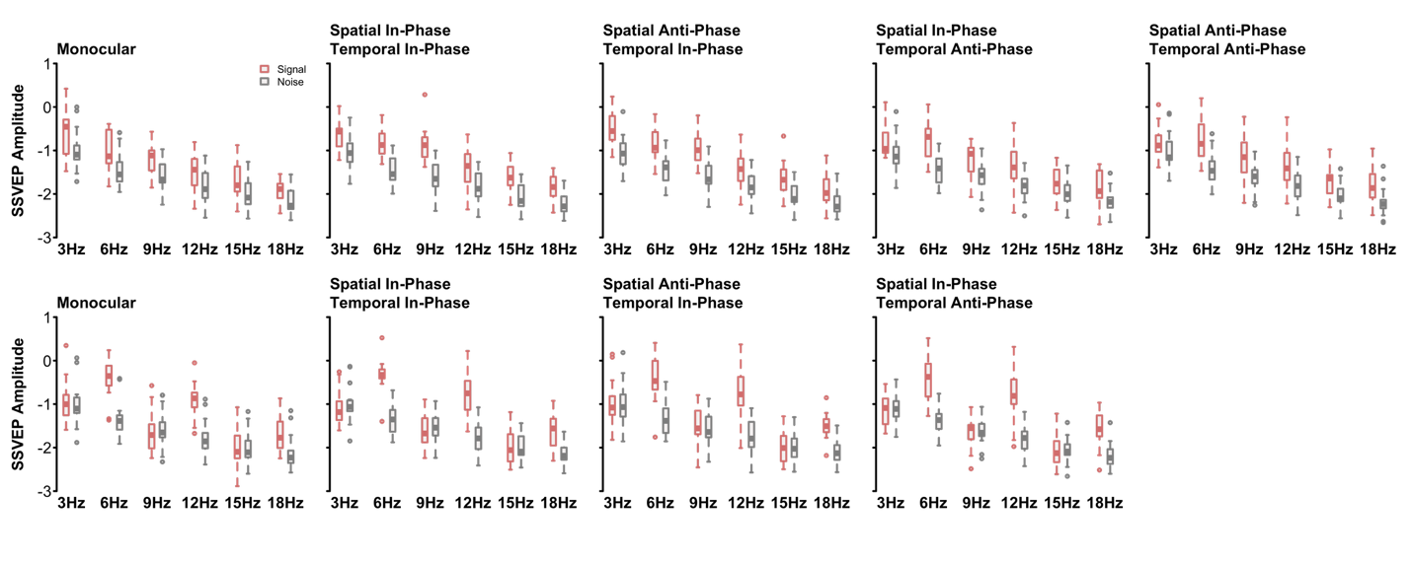
We have also made the same figure of boxplots without a log-transformed y-axis. Here we can see that the pattern is identical, but the association between amplitude and frequency follows the expected power law.
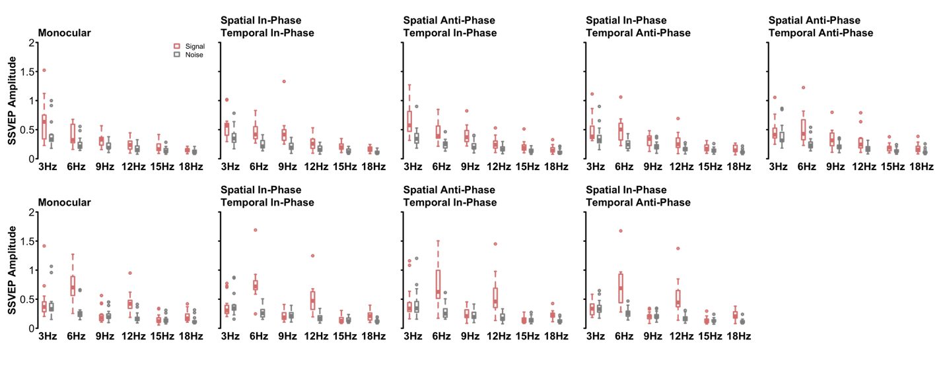
3. Accoring to Wikipedia (if there is a better reference, the authors haven't provided it) mean-squared error can be used as a surrogate for maximum likelihood when errors are normally distributed. Is that the case here? Is it even plausible?

Our AIC calculation uses the Mean Squared Error and thus assumes normality of the residuals. As the reviewer points out, because we are optimizing on the observer SNRs, the residuals will be slightly skewed. However, because we are comparing models within the same family (all are nested within our most complex model) we only care about relative differences in our AIC measures (not the actual value), and our residuals are fairly homoscedastic, we don’t believe using MSE to calculate AIC to be a significant issue.
4. There seems to have been no attempt to address it in the manuscript.
Aggregating across participants to calculate summary statistics is standard in the SSVEP literature (and in many other fields), so we did not see the need to defend this common practice. Regarding “p-hacking” – ideally, we would have pre-registered our study; however, we collected the data in 2017, before this became common practice in our research group. The sample size of N=15 is typical of SSVEP studies. We further point out that the data were collected many years before formal analyses were conducted (in 2025), and that our goal here was primarily to evaluate computational models rather than to establish statistical significance of effects. We have added the following to the Methods (Participants) section:

L. 172 Fifteen observers (N_{male}= 4; age range [19 34]), including authors BR and DHB, participated in this study. The sample size was based on common practice in the field, and is comparable to similar SSVEP studies. All observers had normal or corrected-to-normal visual acuity, as verified by a Snellen chart, and normal binocular vision, as verified by a Titmus test. Written informed consent was obtained from all participants, and experimental procedures were approved by the ethics committee of the Department of Psychology at the University of York. Finally, as the experimental design was exploratory in nature, we did not pre-register the study design or hypotheses.
5. An equation of this form does appear (as Eqn. 5) in Legge's 1984b paper, but a) Legge himself cites Legge and Rubin (1981) for this equation and b) the symbols represent monocular contrasts and a suprathreshold matching stimulus. They do not represent "signals from the two eyes" and an improvement in contrast sensitivity.

The equation presented below the Legge 1984b citation is not a direct copy of the formula in the original manuscript, but an updated interpretation of the original sqrt(Cl²+Cr²) within the framework of the two-stage contrast gain control.

Specifically, the citation refers to the following statement:
L. 38 the binocular improvement in sensitivity (Legge, 1984b) is consistent with a non-linearity operating before the signals from the two eyes (c_{L}and c_{R}) are combined.

We clarified this by moving the citation so that it no longer precedes the equation.
6. ("…can improve by a factor of root 2 or more") I don't care if it is regularly used. It is meaningless. If doubling the input increases performance by a maximum factor of 1.41, then drop the 'or more'. If it increases performance by a minimum factor of 1.41, then replace 'can improve' with 'improves'. If it sometimes increases performance by less than a factor of 1.41 and sometimes increases performance by more than a factor of 1.41, then remove the meaningless sentence altogether!

We have changed this sentence to now read as
L.21 Contrast sensitivity improves by at least √2 when stimuli are presented binocularly rather than monocularly.

